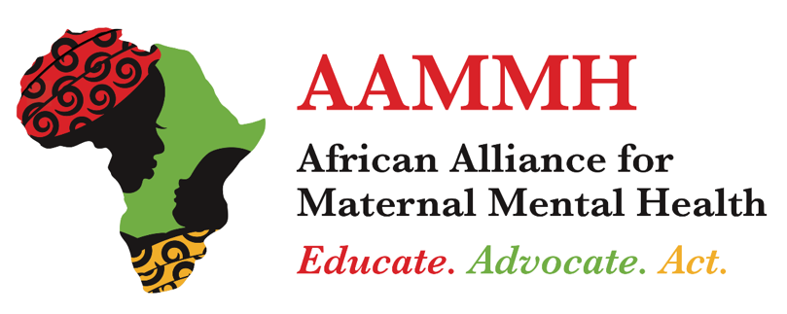

Membership Form
Please complete and email to atu.indira@gmail.com
- Organization name (as it appears on registration certificate and/or constitution):
- Acronym – if used (e.g. AAMMH)
- Details of where registered as an organization (e.g. NGO council) and registration number:
- If not a formally registered organization, please give details/explanation:
- Organization contact details:
Postal address:
Physical address:
Telephone number:
Fax number:
Website:
E-mail:
Facebook:
Twitter:
Other:
- Person who has agreed to be the named contact for the organization (name and position, contact details)
- Organization profile- approx. 150 words. Please provide a brief description of your organization (this will appear on the AAMMH website alongside the organization logo and links) (You can include mission statement, objectives, primary focus, field of work, primary population target group etc.)-
- Date organization established: (year)
- Geographical area the organization works in (i.e. Country/Countries, Region within Country (if relevant):
- Category of your organization (Please indicate with X in checkbox) |  | Checkbox
- Government agency
- Educational Institution
- Health Delivery organization (e.g. hospital)
- Community based organization
- NGO – International
- NGO – local
- Professional association
- Commercial company.
- Other (give details):
- Main Activities (Please indicate with X all applicable activities) |  | Checkbox
- Maternal mental health
- General mental health
- Disability
- Safe motherhood
- Sexual reproductive health rights
- Family planning
- HIV
- Maternal and newborn/child health
- Child health
- Early Childhood Development
- Nutrition
- Advocacy
- Income Generating Activities
- Research
- Education – school level
- Education – higher
- Other (give details):
- What is the involvement in your organization of people with lived experience of the health/social issue that is the focus of the organization? (please indicate with X in checkbox) |  | Checkbox
- People with lived experience lead the organization
- People with lived experience are involved in decision making/implementation
- People with lived experience are direct beneficiaries of your organization
- Details:
- Is your organization a member of any national or international alliances, umbrella organizations etc.? If yes, please list them:
- Is your organization currently engaged in any activities specifically around mental health of mothers? If yes, please give details.
- What information/support etc. would help your organization better meet the mental health needs of the mothers who are part of the organization or with whom you work? (Please indicate all that apply with X in checkbox) |  | Checkbox
  - Link to a resource repository
    - Advocacy materials
    - Clinical guidelines
    - Research publications
  - Web-based educational programmes
  - Information about sources of help for mothers in your area/country
  - Other:
- What skills, resources, staff time etc. could your organization potentially provide to AAMMH?
- Please confirm that your organization supports the aims of the AAMMH (see https://aammh.org/about-us/) and that your organization is committed to act to help meet those aims.
- LOGO for inclusion on our website. Please copy your logo here or email as a separate attachment.
- Do you have any other comments/questions?

